BHTT 2025 Suggested Reading List
SUNDAY, FEBRUARY 2, 2025
Things They Carried: An African Philosophy on War, Surviving Enslavement and Citizenship
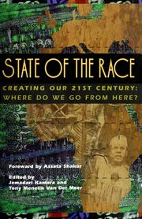

State of the Race: Creating Our 21st Century, Where Do We Go from Here?
By by Jemadari Kamara (Editor), Tony Menelik Van Der Meer (Editor)
Article 1: The Freedom Petitions: Black Patriotism, Black Politics, and the Abolition of Slavery in Massachusetts, 1773-1783
Article 2: African Cosmology and the Duality of Western Hegemony: The Search for an African Identity
Book chapter: Comparative Just War Theory: Chapter Eight: An African Theory of Just Causes for War – by Thaddeus Metz

SUNDAY, FEBRUARY 9, 2025
Hopes and Impediments: War and Strategies for Belonging



Water from the Rock: Black Resistance in a Revolutionary Age
by Sylvia R. Frey
Article 1: African American Service during the Revolution
Article 2: Remembering the Significant Role of the U.S. Colored Troops in America’s History
Article 3: Soldiers and Spirituals: South Carolina US Colored Troops

SUNDAY, FEBRUARY 16, 2025
The Great Migration: Military Service and the Shaping of a Diversified New Hampshire
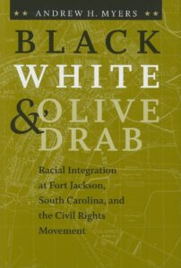

Black, White, and Olive Drab: Racial Integration at Fort Jackson, South Carolina, and the Civil Rights Movement (The American South Series)
by Andrew H. Myers
Article 1: A short history of integration in the US armed forces
Article 2: How the USO Served a Racially Segregated Military Throughout World War II
Article 3: African-American troops at Manchester’s Grenier Field
Article 4: Black Labor and Race Relations in East Bay Shipyards During World War II

SUNDAY, FEBRUARY 23, 2025
Eyes on the Prize: Protests, Movements, and the Road Ahead


This Worldwide Struggle: Religion and the International Roots of the Civil Rights Movement
by Sarah Azaransky
Article 1: Civil rights struggle remembered in N.H.
Article 2: The Role of the Black Church in the American Civil Rights Movement
Article 3: Black History: Timeline of the Post-Civil Rights Era
Article 4: Americans continue to protest for racial justice 60 years after the March on Washington
Article 5: Civil Rights Today

