Mixing DNA results with your paper trail
Dr. Penny Walters
Author of: ‘Ethical Dilemmas in Genealogy’ and ‘The Psychology of Searching’
available in paperback or on Kindle
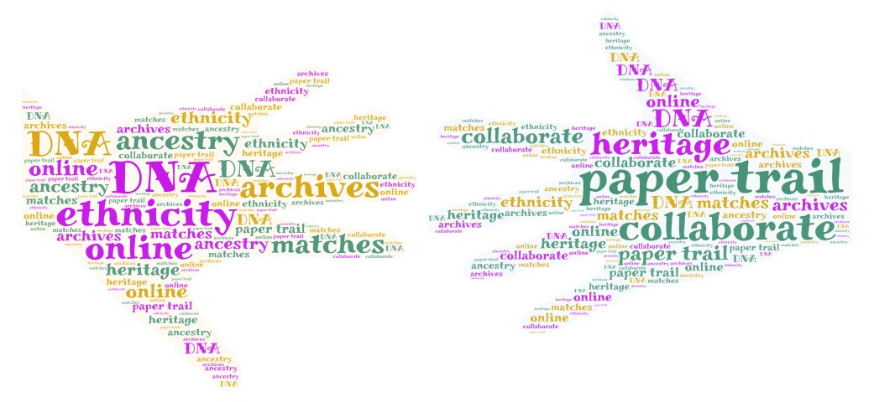
Plan

- typical family tree
- unknown relationship trees
- DNA testing
- DNA matches
- percentages and pie charts
- consanguinity
- relationship predictors
- testing ‘useful’ people
- GEDMatch
- triangulation
- tools
- ethnicity
- ethical dilemmas

DNA testing

I was giving a lecture about researching a tree when you were adopted at a ‘Who Do You Think You Are?’ event in Birmingham, UK. There were DNA kits available and I bought the first test I saw - I didn’t make an informed choice. I knew about ‘paternity testing’ but didn’t know much more about DNA testing. When my DNA test results came back I wasn’t sure what to do next.
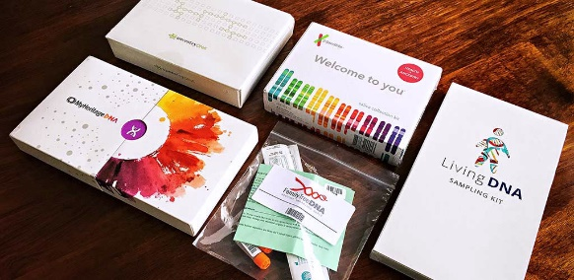

I have subsequently discovered that different tests test different things and each company has its own advantages and disadvantages. I didn’t understand the jargon, and the implications of the results were lost on me.

- mtDNA traces the maternal line
- Y-DNA follows the male line Y-DNA is passed down from father to son - inheritance pattern typically follows the surname
- autosomal DNA analyses the 22 pairs of non-sex chromosomes, which include one from the mother & one from the father; can tell you about both sides of the family
DNA test results reveal an ethnicity estimate, a map, a list of people that your DNA ‘matches’ (overlaps) with, and the opportunity to contact them and collaborate if you both want to.

Pie charts

After my children and my grand-daughter DNA tested, I could see a picture emerging. I knew our relationships, and could work out our percentage overlaps; for example, my daughter would inherit c50% from me, and my grand-daughter would inherit c25%, and so on. I needed to understand this, to work out potential 2nd cousins, for example.
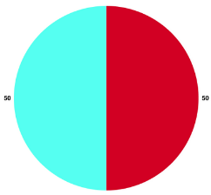

Known relationships

my children: ‘parent/child’ - range from 3,421-3,488cM across 73-85 segments
my grandchildren: ‘close family-1st cousins’ (WHY?) range from 1567-1627cM across 42-46 segments
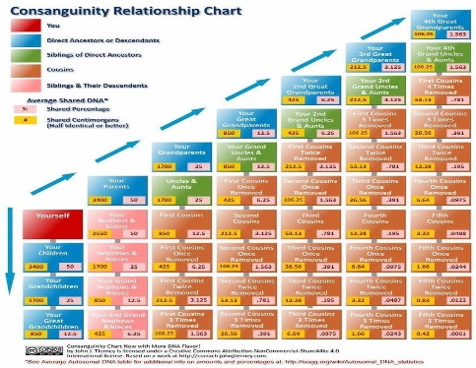

A consanguinity chart (Tierney) is useful, especially for adopted people who may not have as much factual information as other people.

Utilise known relationship DNA results

- my oldest daughter shares 3,421 centimorgans (CMs) across 78 DNA segments with me - labelled parent/child
- my 6 children range from 3,421-3,488cM shared across 73-85 segments
- my first granddaughter shares 1,567 cMs across 42 DNA segments with me (approx. half of my daughter?) -labelled ‘close family - 1st cousin’
- my grandchildren range from 1,567-1,627cM shared across 42-46 segments

Generalise to unknown relationship DNA matches

- my highest DNA match shares 332 cMs shared across 17 DNA segments, predicted 2nd cousin - hasn’t replied to messages; added some information from her public tree
- next highest DNA match shares 32 cMs shared across 3 DNA segments, predicted 4th – 6th cousin - collaborated fully & broadened my information along a whole branch of descendants from our g- grandparents
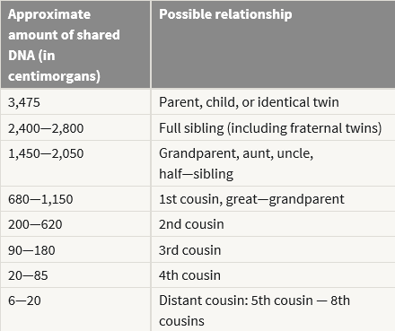

- my daughter -3,421 cMs
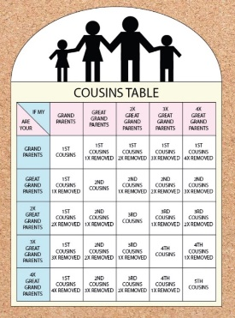
- my granddaughter - 1,567 cMs

Look at potential relationships from amount of DNA overlap, then insert into possible positions on a practice tree, utilising names & places.

Example
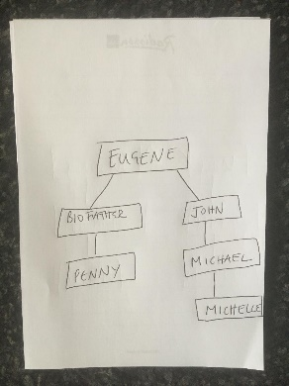

Shared DNA: 6.2% (437.4‎ cM); shared segments 15; largest segment 82.8‎ cM
DNA predicted relationship: 1st cousin once removed/ 1st cousin twice removed/ 2nd cousin
tree relationship: 1st cousin once removed

Be open to a range of possible relationships based on DNA

- match - shared 32cM across 3 segments, predicted 4th - 6th cousin
- actual relationship – 3rd cousin - different to the predicted 1
- the tree position would have been incorrect
- his mother: shared 121 cM across 7 DNA segments, predicted 3rd - 4th cousin
- actual relationship - 2nd cousin once removed

Choose who to ‘usefully’ DNA test

- ideally test elders: available parent/ grandparent/ aunt/ uncle
- no point testing people with the same relationship to you, for example, your 3 siblings
- test someone with a distant but known relationship to you

Ethnicity and inheritance
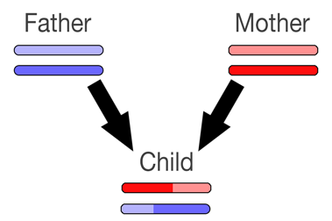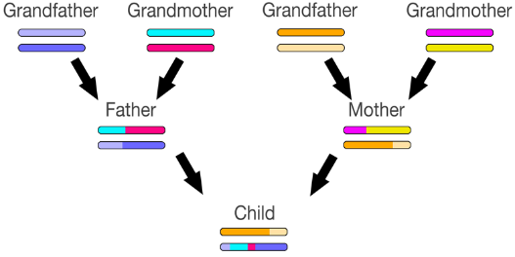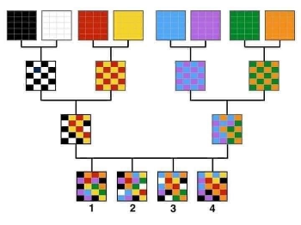

Inheritance seems random, and can raise (unfounded) doubts about paternity.

GedMatch

You can also download your DNA data, and then upload it to a free-to-use website, www.gedmatch.com, which compares the main DNA testing websites, and gives more insights. I had 150 matches on Ancestry, and over 1,000 on GedMatch. Many of those people had tested on other sites, and we would never have overlapped on the separate sites we had chosen. A really useful column on that site is MRCA, most recent common ancestor, which reveals how many generations ago you and your match overlap. There is also the potential for triangulation, where you can see if 2 known relatives overlap with each other, and eliminating people who don’t match both.

Useful tools:

- Bettinger: https://dnapainter.com/tools/sharedcmv4
- Excel spreadsheets
- grouping methods
- Leeds method DNA Color Clustering: The Leeds Method for Easily Visualizing Matches - Dana Leeds
- AutoClusters - groups together DNA Matches that likely descend from common ancestors, in a visual chart

You should decide which relatives you’re searching for and the ‘why’ will then inform the ‘how’

- searching for bio family?
- specifically interested in DNA angle?
- broaden your tree and your narrative?

Ethical dilemmas

‘I’m only doing my tree, what problems can there be?’
- privacy & confidentiality issues
- DNA - very new (do we understand it all)
- opening up ‘a can of worms’ (secrets & lies)

Stay in touch:

Email: penny_walters@talk21.com
Website: www.searchmypast.co.uk
FB Business page: https://www.facebook.com/searchmypast/
FB: https://www.facebook.com/penny.walters.52
Twitter: https://twitter.com/DrPennyW

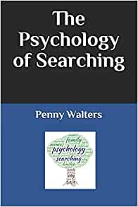
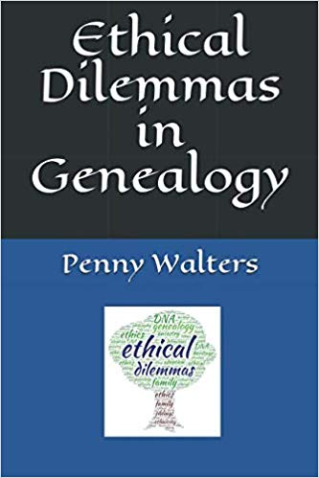
Author of:
- ‘Ethical Dilemmas in Genealogy’ 2019. ISBN: 9781724038241
- ‘The Psychology of Searching’ 2020.
ISBN: 9781687167262

